**"Deep Learning-Based Melanoma Cancer Detection: Leveraging CNN Models and Transfer Learning"**

**ABSTRACT:**

The creation and assessment of deep learning models for the identification of melanoma cancer, a highly deadly type of skin cancer, is the main goal of this research project. Due to the difficulty of analysing skin lesions and the necessity of an early diagnosis for successful therapy, melanoma detection presents considerable hurdles. To tackle these issues, in this work, we utilise convolutional neural network (CNN) models enhanced by transfer learning methods. In order to improve model performance, the study investigates a number of preprocessing techniques, such as picture augmentation and normalisation, using a carefully selected dataset of melanoma photos. We also examine the effectiveness of transfer learning by optimising CNN architectures that have already been trained, such ResNet50. The outcomes of the experiment show how well the suggested method works to correctly identify benign lesions and melanoma. We also examine the models' interpretability and talk about how they might be used in dermatology clinical settings. All things considered, this study advances automated melanoma detection methods, makes early diagnosis easier, and enhances patient outcomes.

**INTRODUCTION:**

Melanoma is a cancer that starts in melanocytes and is extremely dangerous since it can spread to other parts of the body and is aggressive. Subjectivity and resource limitations plague traditional diagnostic procedures that rely on dermatologists' subjective visual assessment. Enhancing melanoma detection efficiency and accuracy through the use of deep learning innovations, including convolutional neural networks (CNNs) and transfer learning, presents a potential path.

The goal of this research project is to create automated melanoma detection models using CNN-based models enhanced with transfer learning approaches. Through the use of a carefully selected dataset of melanoma photos, the research aims to create models that can reliably distinguish between benign and malignant lesions. Additionally, the study looks into how preprocessing methods like image augmentation and normalisation affect the robustness of the model to changes in image quality and its performance.

The study hopes that these efforts will further automated melanoma detection systems, which will help with early diagnosis and better patient outcomes in the fight against melanoma cancer.

**Aim and Objectives:**

The aim of this project is to develop and evaluate deep learning models for automated melanoma cancer detection, leveraging convolutional neural networks (CNNs) and transfer learning techniques.

The research objectives are formulated based on the aim of this study which are as follows:

* To curate a diverse dataset of melanoma images, including both malignant and benign lesions, from reputable sources or medical databases.
* To preprocess the dataset by standardizing sizes, applying image augmentation techniques, and normalizing pixel values to enhance model generalization and robustness.
* To select appropriate CNN architectures and investigate variations in model complexity, filter sizes, and activation functions for the melanoma detection task.
* To leverage transfer learning by fine-tuning pre-trained CNN models, such as ResNet50, on the melanoma dataset to enhance model performance.
* To train and evaluate the CNN models using a split dataset into training, validation, and testing sets, optimizing hyperparameters and preventing overfitting through validation techniques.
* To measure model performance using metrics such as accuracy, precision, recall, F1-score, and area under the receiver operating characteristic curve (AUC-ROC).

**Literature Survey:**

This paper[1]evaluates six transfer learning nets for skin cancer classification, using data augmentation to address dataset imbalances. exception Net stands out with 90.48% accuracy, offering high recall, precision, and F-measure values. Improved early detection aids in treating skin cancer, potentially saving lives, particularly in the context of COVID-19-induced ozone layer recovery. Further research is needed to refine transfer learning algorithms for even better accuracy in diagnosing skin cancer. This study[2] introduces a deep learning model based on transfer learning with a modified VGG16 architecture to detect skin cancer early. Through extensive experimentation, the model achieves an impressive accuracy of 89.09%, surpassing existing techniques. While the model shows promise, further enhancements are suggested to increase both true positive and true negative rates, indicating room for improvement in skin cancer detection. The findings highlight the potential for more refined models to aid dermatologists in diagnosing skin cancers accurately and swiftly. The study[3]proposes a Transfer Constituent Support Vector Machine (TrCSVM) framework for melanoma classification using transfer learning. It combines feature-based domain adaptation with SVM and Transfer AdaBoost to address data insufficiency issues. TrCSVM enhances representation transfer between domains and adjusts data weights for improved classification accuracy. This study[4]addresses challenges in skin lesion diagnosis using computer-aided methods. Leveraging the MNIST HAM10000 dataset, it employs image preprocessing and NASNet model for lesion detection. Experimental results showcase a high accuracy of 99.85%, attributed to data augmentation and multi-step image processing techniques. This paper[5]explores the use of deep convolutional neural networks (DCNN) for early detection of skin cancer, employing image segmentation and classification techniques. With an emphasis on accuracy and efficiency, the models achieved promising results, demonstrating potential for future enhancements in skin cancer detection. The research was supported by the Artificial Intelligence in Healthcare Researcher Chair at Princess Nourah bint Abdulrahman University, acknowledging key contributors and sponsors. This study[6]introduces a deep learning system on a GPU server for early detection of melanoma, potentially aiding dermatologists in diagnosis. Utilizing pre-trained convolutional neural networks, the method demonstrates superior diagnostic accuracy, showing promise for improving melanoma detection. The research highlights the effectiveness of deep learning in extracting patterns from skin lesion images, offering advancements in early detection methods.This paper[7]introduces an explainable CNN-based stacked ensemble framework for early detection of melanoma skin cancer, addressing the interpretability challenge of deep CNN models. By combining multiple CNN sub-models and employing a meta-learner, the framework achieves high accuracy (95.76%), sensitivity (96.67%), and AUC (0.957). The use of shapely adaptive explanations generates heatmaps, aiding dermatologists in understanding the model's decision process, enhancing trust and usability in clinical settings. This study[8]addresses the challenges of skin lesion detection using computer-aided diagnosis, focusing on Melanocytic lesion classification. Utilizing the MNIST HAM10000 dataset, the research emphasizes image preprocessing and employs the NASNet model, achieving an impressive accuracy of 99.85% through data augmentation and multi-step image processing techniques. The proposed model offers promising advancements in automated skin cancer detection, enhancing efficiency and accuracy in diagnosis. This study[9]focuses on improving melanoma detection accuracy using deep learning CNN frameworks, leveraging neural networks' customization capabilities. By exploring models like ResNet, DenseNet, Inception, and VGG with the HAM10000 dataset containing seven lesion types, the research achieves promising results, diversifying precision factors and input qualities. The findings underscore the potential of tailored deep learning approaches in enhancing melanoma diagnosis. This paper[10]introduces a novel approach combining machine learning and deep learning techniques for skin cancer detection, achieving a high accuracy of 93%. By leveraging state-of-the-art neural networks and manual feature extraction methods like Contourlet Transform and Local Binary Pattern Histogram, the model demonstrates superior performance compared to expert dermatologists and other existing methods. The proposed ensemble method offers significant assistance to dermatologists in preventing misdiagnosis, highlighting its potential in improving skin cancer diagnosis accuracy. This article[11]explores skin lesion classification using CNN techniques, achieving high accuracy without data augmentation. By merging VGG16 and VGG19 architectures into a modified AlexNet and fine-tuning on dermatology images, the proposed model achieves a significant 3% improvement in classification accuracy, reaching 98.18%. The study highlights the effectiveness of transfer learning and proper network design in enhancing skin cancer detection. This study[12]presents a deep learning model based on transfer learning using a modified VGG16 architecture for skin cancer detection, achieving an accuracy of 89.09% on a Kaggle dataset. By incorporating data augmentation techniques and optimizing hyperparameters, the model outperforms state-of-the-art techniques, aiding dermatologists in early diagnosis. Further enhancements are suggested to improve both true positive and true negative rates, indicating ongoing potential for refining skin cancer detection models. This study introduces a convolutional neural network architecture for melanoma diagnosis, integrating ensemble learning and genetic algorithms to optimize model selection. By merging abstract features from multiple models, the approach improves convergence, mitigates overfitting, and enhances generalization performance. Experimental results demonstrate superior prediction performance compared to state-of-the-art models, with an 11% and 13% improvement in dermoscopic and non-dermoscopic images, respectively, and is accessible via a web application for dermatologists. This research[14]compares traditional Convolutional Neural Networks (CNN) with Vision Transformer (ViT) for skin cancer classification, finding EfficientNet-B3 to perform best among the models tested. The study fine-tunes pre-trained ViT models on ImageNet datasets and evaluates their performance, highlighting the effectiveness of ViT in skin cancer classification tasks. EfficientNet-B3 outperforms other CNN models and ViT configurations with the same input image resolution. This study[15]combines deep learning and transfer learning to classify prostate cancer using MRI images, achieving an accuracy rate of 88.89%. Leveraging the EfficientNet architecture and three branches for feature extraction, the proposed methodology outperforms traditional hand-crafted feature techniques and existing deep learning methods in PCa classification. The innovative approach streamlines the assessment process for radiologists, mitigating diagnostic errors and offering high-precision prostate cancer classification.

**Methodologies:**

The Dataset of Melanoma cancer detection is taken from Kaggle.Curate a diverse dataset of melanoma images, including both malignant and benign lesions, from reputable sources or medical databases.Ensure proper annotation and labeling of the dataset to facilitate supervised learning.Preprocess the images by standardizing sizes, applying image augmentation techniques (e.g., rotation, flipping, scaling), and normalizing pixel values to enhance model generalization and robustness.Choose appropriate CNN architectures for the melanoma detection task, considering factors such as model complexity, computational resources, and previous performance in similar medical imaging tasks.Experiment with variations of CNN architectures, including different numbers of layers, filter sizes, and activation functions, to identify the most suitable architecture for the task.

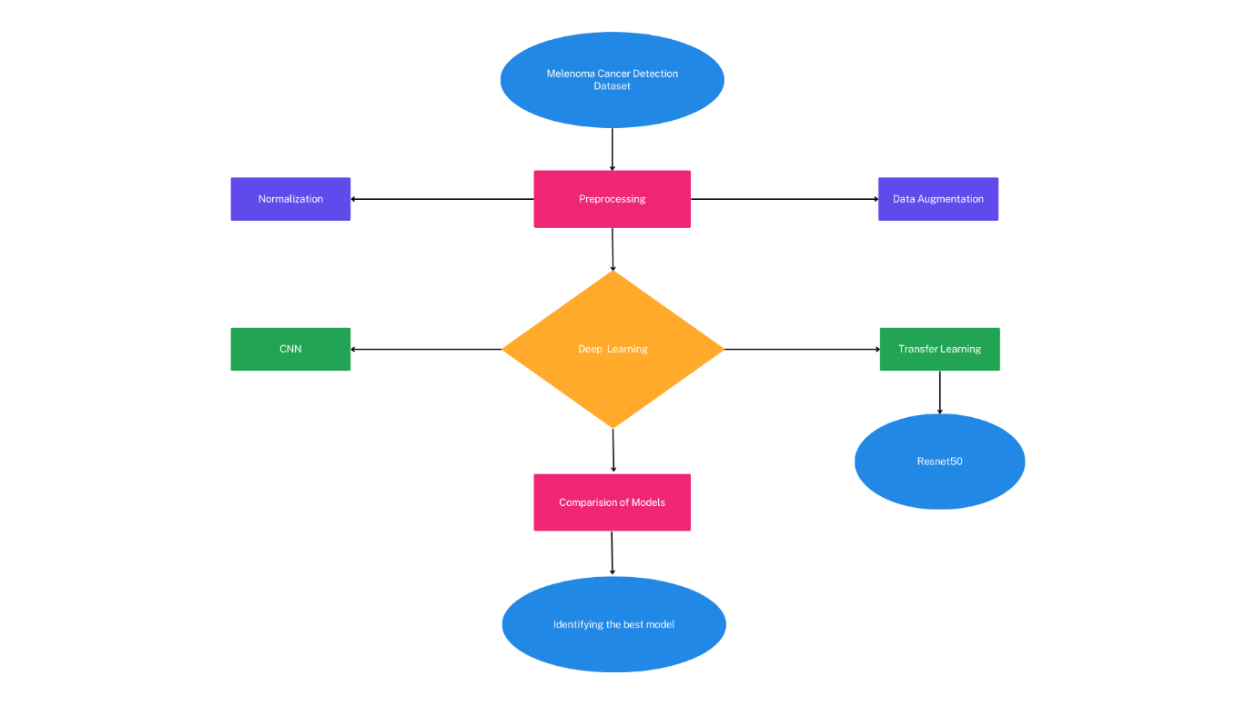

**Methodologies used**

We Utilize transfer learning to leverage pre-trained CNN models, such as ResNet50 or VGG16, trained on large-scale image datasets like ImageNet.Fine-tune the pre-trained models on the melanoma dataset by adjusting the weights of the final layers while preserving the learned features from the pre-trained layers.

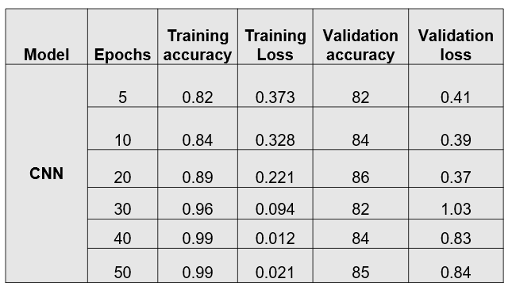

**Model Training and Evaluation**

Split the dataset into training, validation, and testing sets to train and evaluate the models. Train the CNN models using the training set, optimizing hyperparameters such as learning rate and batch size to minimize loss and maximize accuracy.Validate the models on the validation set to monitor performance and prevent overfitting through early stopping or regularization techniques.Evaluate the trained models on the independent testing set to assess their generalization performance and compare against baseline methods or clinical benchmarks.

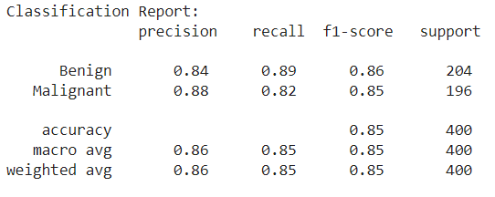

**Accuracy, precision, recall, F1-score, and area**

Measure model performance using metrics such as accuracy, precision, recall, F1-score, and area under the receiver operating characteristic curve (AUC-ROC).Analyze and interpret the predictions of the trained models, including visualizing activation maps and feature importance to understand the decision-making process.Compare the performance of the proposed CNN models with existing methods and assess their clinical relevance and potential for deployment in real-world settings.

By following these methodologies, the project aims to develop robust and accurate CNN models for automated melanoma detection, contributing to advancements in early diagnosis and patient care in dermatology.

**References:**

1. Jain, S.; Singhania, U.; Tripathy, B.; Nasr, E.A.; Aboudaif, M.K.; Kamrani, A.K. Deep Learning-Based Transfer Learning for Classification of Skin Cancer. Sensors 2021, 21, 8142.

2. Anand, V.; Gupta, S.; Altameem, A.; Nayak, S.R.; Poonia, R.C.; Saudagar, A.K.J. An Enhanced Transfer Learning Based Classification for Diagnosis of Skin Cancer. Diagnostics 2022, 12, 1628.

3. Singh, L., Janghel, R.R. and Sahu, S.P. (2021), "TrCSVM: a novel approach for the classification of melanoma skin cancer using transfer learning", Data Technologies and Applications, Vol. 55 No. 1, pp. 64-81.

4. Altamimi, A., Alrowais, F., Karamti, H., Umer, M., Cascone, L., & Ashraf, I. (2024). An improved skin lesion detection solution using multi-step preprocessing features and NASNet transfer learning model. Image and Vision Computing, 144.

5. Hanan Aljuaid, Arwa Alhammad, Noura Alsakran, Rafaf Alnoghaimshi, Fay Aldhafer, Yara Alahmari, "Segmentation of Skin Cancer and Intensity Classification Using Deep Convolutional Neural Network", 2023 Congress in Computer Science, Computer Engineering, & Applied Computing (CSCE), pp.723-728, 2023.

6. Waheed, S. R., Saadi, S. M., Rahim, M. S. M., Suaib, N. M., Najjar, F. H., Adnan, M. M., & Salim, A. A. (2023). Melanoma skin cancer classification based on CNN deep learning algorithms. Malaysian Journal of Fundamental and Applied Sciences, 19(3), 299-305.

7. Shorfuzzaman, M. (2022). An explainable stacked ensemble of deep learning models for improved melanoma skin cancer detection. Multimedia Systems, 28(4), 1309-1323.

8. Altamimi, A., Alrowais, F., Karamti, H., Umer, M., Cascone, L., & Ashraf, I. (2024). An improved skin lesion detection solution using multi-step preprocessing features and NASNet transfer learning model. Image and Vision Computing, 144, 104969.

9. Girdhar, N., Sinha, A., & Gupta, S. (2023). DenseNet-II: An improved deep convolutional neural network for melanoma cancer detection. Soft computing, 27(18), 13285-13304.

10. Tembhurne, J. V., Hebbar, N., Patil, H. Y., & Diwan, T. (2023). Skin cancer detection using ensemble of machine learning and deep learning techniques. Multimedia Tools and Applications, 82(18), 27501-27524.

11. Faghihi, A., Fathollahi, M., & Rajabi, R. (2023). Diagnosis of skin cancer using VGG16 and VGG19 based transfer learning models. Multimedia Tools and Applications, 1-16.

12. Anand, V., Gupta, S., Altameem, A., Nayak, S. R., Poonia, R. C., & Saudagar, A. K. J. (2022). An Enhanced Transfer Learning Based Classification for Diagnosis of Skin Cancer. Diagnostics 2022, 12, 1628.

13. Pérez, E., & Ventura, S. (2022). An ensemble-based convolutional neural network model powered by a genetic algorithm for melanoma diagnosis. Neural Computing and Applications, 34(13), 10429-10448.

14. Ashfaq, M., & Ahmad, A. (2023). Skin Cancer Classification with Convolutional Deep Neural Networks and Vision Transformers Using Transfer Learning. In Advances in Deep Generative Models for Medical Artificial Intelligence (pp. 151-176). Cham: Springer Nature Switzerland.

15. Mehmood, M., Abbasi, S. H., Aurangzeb, K., Majeed, M. F., Anwar, M. S., & Alhussein, M. (2023). A classifier model for prostate cancer diagnosis using CNNs and transfer learning with multi-parametric MRI. Frontiers in Oncology, 13, 1225490.